Animal Research
Think-Tac-Toe Board
TAG Scholar:_____________________________________Date:____________________
Using Pebblego.com, research information on any animal of your choice. Create a picture book about your animal. It should have three pages.  - What does it look like?  - What does it eat?  - What is the life cycle of your animal?  Be sure to illustrate each page. Feel free to include more information. | Research two animals of your choice. Create a Venn Diagram comparing and contrasting facts about the two animals. Include three fact in each area.  Animal A Same Animal B
Create a Diaroma “a life-size, three-dimensional scene from nature” about your animal/habitat. See directions below.  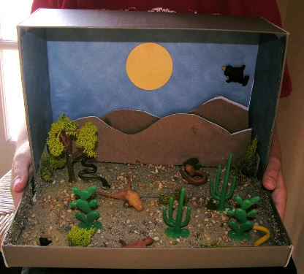  This Photo by Unknown Author is licensed under CC BY | Write a letter to your teacher convincing him/her to have a classroom pet. What animal would be a good choice? How will it help the students in the classroom? Who would take care of it?  This Photo by Unknown Author is licensed under CC BY-SA
Pebblego.com Username: medlockbridge Password: school
Try one, some or try them all!
Keep in mind, these activities are to enrich. Your assignments from your reading and math teachers take precedence and should be completed before attempting activities from the think-tac-toe board.
I look forward to seeing your work. Activities can be completed:
  - K/1 On paper – take a picture, upload it and email me your work.
- 2nd Graders – you can use Office 365 (Word, PowerPoint, Sway) – share with me (fosterm2@fultonschools.org)
HOW TO MAKE A DIORAMA
1. Find a box at least as big as a shoe box - a slightly larger box works even better. Cover the outside of
the box with construction paper.
2. Collect your materials - animal figures, palm trees or sugar cubes to build an igloo, for an interior scene.
3. Decide on a background - you can paint or draw your own or use wallpaper, construction paper or wrapping paper (or anything else you can find). You can paint them or color them with markers, crayons or paint.
4. Build your diorama working from the back to the front - start with the background (don't forget the
sky/ceiling and ground/floor). Then place large objects such as trees.
5. Attach a title to the box where it can easily be seen.

